DIFO 2017 - Lab 1 Report

Group number: Group 14

Group members: Wisam Faik, Md Piar Hossain, Cecilia To

# Exercise 1 - Hashing

**Objective:** Our objective for this exercise was to find the hash values of all four files and to verify the hash values match from a text file that contains all the hash values of the four files.

**Tools**: md5deep64.exe version 4.4, sha256deep64.exe version 4.4 and whirlpooldeep64.exe version 64.

* **What files (and/or folders) did you hash?**

’hello’, ’hello (2)’, ’hello (3)’ and ’hello (4)’ files were all hashed using md5deep64.exe, sha256deep64.exe and whirlpooldeep64.exe.

The commands used were:

1. *This is using md5deep64:*

> C:\...path…\md5deep64.exe hello

da5c61e1edc0f18337e46418e48c1290 ” hello”

> C:\...path…\md5deep64.exe ”hello (2)”

cdc47d670159eef60916ca03a9d4a007 ”hello (2)”

> C:\...path…\md5deep64.exe ”hello (3)”

cdc47d670159eef60916ca03a9d4a007 ”hello (3)”

> C:\...path…\md5deep64.exe ”hello (4)”

da5c61e1edc0f18337e46418e48c1290 ” hello”

1. *This is using sha256deep64:*

> C:\...path…\sha256deep64.exe hello

fad878bd261840a4ea4a8277c546d4f46e79bbeb60b059cee41f8b50e28d0e88 C:\...path…\hello

> C:\...path…\sha256deep64.exe “hello (2)”

1316543942a8c6cd754855500cd37068edbbd8b31c4979d2825a4e799fed6102 “C:\...path…\hello (2)”

> C:\...path…\sha256deep64.exe “hello (3)”

60d13913155644883f130b85eb24d778314014c9479aedb5f6323bf38ad3a451 “C:\...path…\hello (3)”

> C:\...path…\sha256deep64.exe “hello (4)”

1c4ff4e490b15b2b214f26c5654decccbcbea9eb900f88649dc7b1e42341be56 “C:\...path…\hello (4)”

1. *This is using whirlpooldeep64:*

> C:\...path…\whirlpooldeep64.exe “C:\...path…\hello”

1f4388f4a81a6cfacde955cf5fd84c4e76f12876db3356e2a84efda91f8c44407b3626b770d9752f9b0aa05927e7fb7c66e07ea96ea47ece2ca78a40cedb9d7e

> C:\...path…\whirlpooldeep64.exe “C:\...path…\hello (2)”

aae0a840704962b3026cf5b2058aa1a3d7752e6d562e0a843ce0abf7107666fb475ac45df08587c468f7754847f2be4cebd1172dedfebfaa6527c8da2b1bc364

> C:\...path…\whirlpooldeep64.exe “C:\...path…\hello (3)”

959593fe62721c9d058831eaa742f103d1b853b43a81a94dd30cc89a6dafb6926b64bdd7b0ef16a4c566601f81af95988fb952720482562a6269728ef5f5d5fb

> C:\...path…\whirlpooldeep64.exe “C:\...path…\hello (4)”

4324731f2340b0d5ce741f566abd7ebf8a1c18a15e4835bd8c25bdc974ec275a6e088982422456060bf145d7013cd0aa8ac1b62ee3f8149bfd6490e6a5a95efa

* **Which algorithms did you choose?**

Initially, we only used md5 algorithm and we noticed using md5, the ’hello’ with ’hello (4) files would have the same hash values where ’hello (2)’ with ’hello (3)’ files would also have the same hash values. Because of this finding, we decided to use sha256 and whirlpool algorithms to ensure and confirm if these files truly would have the same hash values. While using sha256 and whirlpool algorithms, we discovered the hash values were not the same for all four files.

The algorithms chosen for hashing ’hello’, ’hello(2)’, ’hello(3)’ and ’hello(4)’ were sha256, whirlpool and md5. The reason algorithm sha256 and whirlpool generated different hash values were: sha256 digested input message length up to 264 bits in length and whirlpool digested input message length up to 2256 which resulted into different hash values for all four files. Whirlpool generated 512 bits length and sha256 generated 256 bits length.

* **Suppose you would need to calculate the hash sums of several files and folders, how could you do that using the tools and resources provided? Provide a description and exact commands.**

According to the http://md5deep.sourceforge.net/[[1]](#footnote-1), ’-r’ flag can be used to hash all files within a folder recursively. This ’–r’ option doesn’t hash the folder but only the files inside a folder.

Command used:

*> C:\..input path…\whirlpooldeep64.exe -t -r C:\..input folder path > output\_whirlpool.txt*

Results from Output\_test.txt:

1f4388f4a81a6cfacde955cf5fd84c4e76f12876db3356e2a84efda91f8c44407b3626b770d9752f9b0aa05927e7fb7c66e07ea96ea47ece2ca78a40cedb9d7e 2017:09:14:12:27:34 C:\Users\cs2lab\Desktop\Shared\_Folder\DiFo2017\Lab1\Exercise1\_Hashing\test\hello

959593fe62721c9d058831eaa742f103d1b853b43a81a94dd30cc89a6dafb6926b64bdd7b0ef16a4c566601f81af95988fb952720482562a6269728ef5f5d5fb 2017:09:14:12:27:34 C:\Users\cs2lab\Desktop\Shared\_Folder\DiFo2017\Lab1\Exercise1\_Hashing\test\hello (3)

aae0a840704962b3026cf5b2058aa1a3d7752e6d562e0a843ce0abf7107666fb475ac45df08587c468f7754847f2be4cebd1172dedfebfaa6527c8da2b1bc364 2017:09:14:12:27:34 C:\Users\cs2lab\Desktop\Shared\_Folder\DiFo2017\Lab1\Exercise1\_Hashing\test\hello (2)

4324731f2340b0d5ce741f566abd7ebf8a1c18a15e4835bd8c25bdc974ec275a6e088982422456060bf145d7013cd0aa8ac1b62ee3f8149bfd6490e6a5a95efa 2017:09:14:12:27:34 C:\Users\cs2lab\Desktop\Shared\_Folder\DiFo2017\Lab1\Exercise1\_Hashing\test\hello (4)

*> C:\..input path… \md5deep64.exe -t –r C:\..input folder path > output\_md5.txt*

Results from Output\_test.txt:

da5c61e1edc0f18337e46418e48c1290 2017:09:14:12:27:34 C:\Users\cs2lab\Desktop\Shared\_Folder\DiFo2017\Lab1\Exercise1\_Hashing\test\hello

cdc47d670159eef60916ca03a9d4a007 2017:09:14:12:27:34 C:\Users\cs2lab\Desktop\Shared\_Folder\DiFo2017\Lab1\Exercise1\_Hashing\test\hello (2)

cdc47d670159eef60916ca03a9d4a007 2017:09:14:12:27:34 C:\Users\cs2lab\Desktop\Shared\_Folder\DiFo2017\Lab1\Exercise1\_Hashing\test\hello (3)

da5c61e1edc0f18337e46418e48c1290 2017:09:14:12:27:34 C:\Users\cs2lab\Desktop\Shared\_Folder\DiFo2017\Lab1\Exercise1\_Hashing\test\hello (4)

*> C:\..input path… \shar256deep64.exe –r C:\..input folder path > output\_md5.txt*

Results from Output\_test.txt:

fad878bd261840a4ea4a8277c546d4f46e79bbeb60b059cee41f8b50e28d0e88 C:\Users\cs2lab\Desktop\Shared\_Folder\DiFo2017\Lab1\Exercise1\_Hashing\test\hello

1316543942a8c6cd754855500cd37068edbbd8b31c4979d2825a4e799fed6102

C:\Users\cs2lab\Desktop\Shared\_Folder\DiFo2017\Lab1\Exercise1\_Hashing\test\hello (2)

60d13913155644883f130b85eb24d778314014c9479aedb5f6323bf38ad3a451 C:\Users\cs2lab\Desktop\Shared\_Folder\DiFo2017\Lab1\Exercise1\_Hashing\test\hello (3)

1c4ff4e490b15b2b214f26c5654decccbcbea9eb900f88649dc7b1e42341be56 C:\Users\cs2lab\Desktop\Shared\_Folder\DiFo2017\Lab1\Exercise1\_Hashing\test\hello (4)

* **Come up with an efficient way to match hash sums – so that you can automatically identify files that might (or might not be) of interest. Describe how you did this and which exact programs you used, and reflect upon why this might be useful for a forensic examiner in their work life.**

The *findstr* command could be used to match and verify hash values of a file but this method was not as efficient as using the *md5deep64.exe, sha256deep64.exe* and *whirlpooldeep64.exe* with the ‘-m’ option directly. We also used ‘-r’ to recursively hash all files in a folder. The reason was *findstr* was not a tool to generate hash values. It would only to search string values and compared the string to a file that contained the particular searched string. With *md5deep64.exe, sha256deep64.exe* and *whirlpooldeep64.exe,* they would generate hash values and would match the hash values of the files to the file that would contain the hash values to be verified.

Example commands used were:

*> C:\..input path…\md5deep64.exe -rm C:\..input folder path…\*

*> C:\..input path…\sha256deep64.exe -rm C:\..input folder path…\*

*> C:\..input path…\whirlpooldeep64.exe -rm C:\..input folder path…\*

The test files we used are in our test folder such as:

install61.iso (214428 KB), test1.txt (1KB), test2.txt(1KB), md5\_hash.txt(1KB), fciv.exe(83KB) and Suspicious\_File (1274KB).

These files were located in the *C:\..input path…\.*

There were other options that could be used for more efficient matching of hash values, they were:

‘-i|I’ by specifying the threshold of the file sizes

‘-jnn’ by generating hash values in multithread method instead sequentially

‘-o’ by specifying what file type to hash

When using ‘-i’ option, it would be more efficient if all files were a particular size that was less than specified threshold value. This would only generate the hash values for only those files under the threshold.

With using ‘-jnn’, this would allow for a large file or many sets of files to be hashed and would generate hash values in a multithread method. It is more efficient because it would create one producer thread to scan the file system and one hashing thread per CPU core[[2]](#footnote-2) of the machine performance.

By using ‘-o’, one could specify what file type to hash instead of generating hash values for all files.

* **Which hashing algorithms did you use? How long did each algorithm take to run?**

We used md5 and sha256 algorithms to hash our test files. The test files used for this timing algorithms test are install61.iso (214428 KB), test1.txt (1KB), test2.txt(1KB), md5\_hash.txt(1KB), fciv.exe(83KB) and Suspicious\_File (1274KB).

With md5 algorithm took 511milliseconds where sha256 algorithm took 1725milliseconds.

Example commands used were:

> measure-command {C:\..input path…\md5deep64.exe -r C:\..input folder path…\ | Out-File test\_md5.txt}

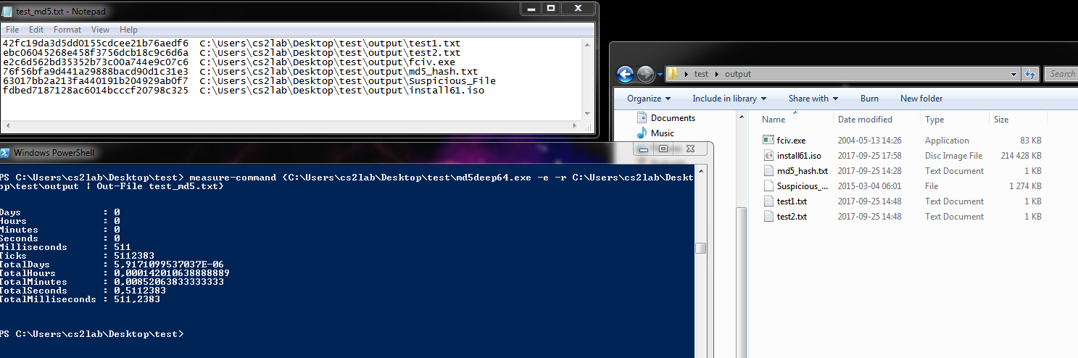

> measure-command {C:\..input path…\sha256deep64.exe -r C:\..input folder path…\ | Out-File test\_sha256.txt}

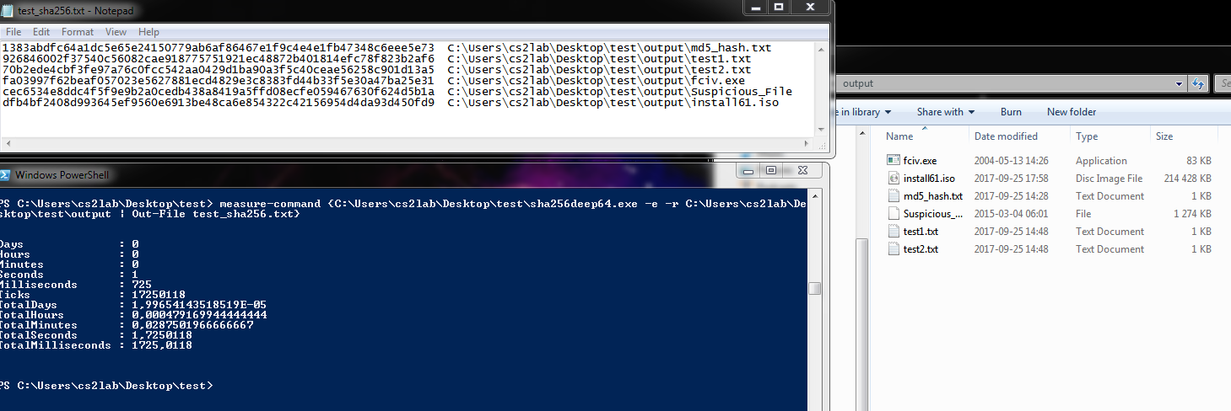

# Exercise 2 - File Headers

**Objective:** Acquire data by acquisition to ensure the integrity of evidence is read-only prior to analyzing the data.

**Chain-of-custody**: generated hash values for all evidence acquired.

**Tools used:** We used these TrID version 1.80, AccessData FTK Imager version 3.4.2.6, HexEdit version 4.0 and Exiftool version 10.6.1.0 to identify the filer header and footer information. All twelve files’ header hexadecimal values were identified by using the Gary Kessler File Signature Table[[3]](#footnote-3).

**With File: 01**

Result for file 01: We were able to identify this file to be a JPEG file because the file header hexadecimal values (FF D8 FF E0 00 10 4A 46 49 46 00) matched to the Gary Kessler File Signature table. But with TrID, it provided matching based on percentage of accuracy. There were four matching found for file ‘01’ using TrID. 38.1 % and 28.6% of JPG file type matching but there were also 23.8% and 9.5% matching to MP3 file type. See table below.

|  |  |  |  |
| --- | --- | --- | --- |
| Tools | File type | Header | Footer/trailer |
| FTK imager | JFIF - JPEG | FF D8 FF E0 00 10 4A 46 49 46 00 | FF D9 |
| HexEdit | JFIF - JPEG | FF D8 FF E0 00 10 4A 46 49 46 00 | FF D9 |
| TrID | 38.1% matching JPG  28.6% matching JPG  23.8% matching MP3  9.5% matching MP3 | N/A | N/A |
| Exiftool | JPEG | N/A | N/A |

FTK Imager with mode set to hex-viewer automatic, a picture of WWII airplanes. To confirm that this file was a jpeg file, we renamed the 01 file to *’01.jpg’*, see figure 1.

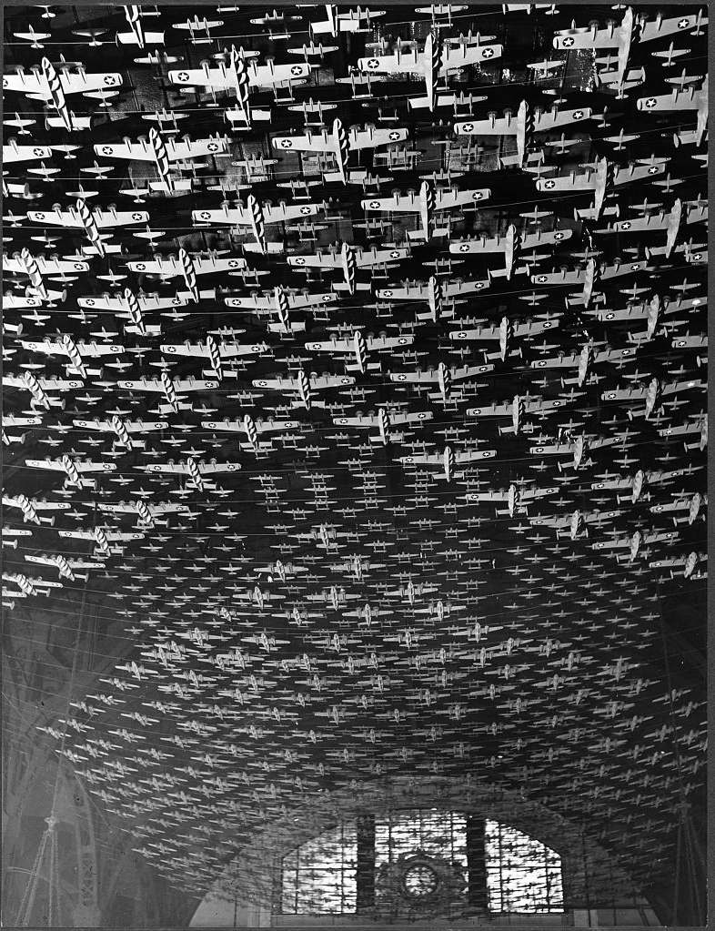

Figure-1: WWII airplanes.

**With File: 02**

Result for file 02: We were able to identify this file to be a GIF file, see table below. With FTK Imager: when mode was set to hex-view automatic, ‘02’ file was shown as GIF file type with a picture of Bipolar Direct-Current. See table below:

|  |  |  |  |
| --- | --- | --- | --- |
| Tools | File type | Header | Footer/trailer |
| FTK Imager | GIF87ag | 47 49 46 38 37 61 67 01 | 00 3B (.;) |
| HexEdit | GIF87ag | 47 49 46 38 37 61 67 01 | 00 3B (.;) |
| TrID: | 60% matching GIF,  30% matching GIF | N/A | N/A |
| ExifTool | GIF | N/A | N/A |

Also to confirm, we renamed the ’02’ file to ’02.gif’and it opened up to:

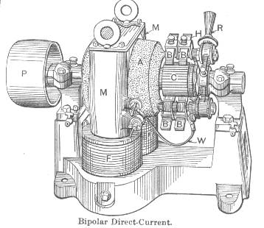

Figure-2: 02.gif

**With File: 03**

Result for file 03: We were able to identify this file to be an internet shortcut because according to Gary Kessler File Signature Table, there was no file type matching the file header hexadecimal information that we had retrieved from FTK Imager and HexEdit. But according to TrID, it found matching to URL for 91.7% and 8.3 for INI file type. See table below.

|  |  |  |  |
| --- | --- | --- | --- |
| Tools | File type | header | Footer/trailer |
| FTK Imager  Note: mode automatic displays as:  [InternetShortcut]  URL=http://www.dc3.mil/challenge/  Modified=70C990463628CB0139 | [InternetShortcut] | 5B 49 6E 74 65 72 6E 65-74 53 68 6F72 74 63 75 74 5D | No footer |
| HexEdit  [InternetShortcut]  URL=http://www.dc3.mil/challenge/  Modified=70C990463628CB0139 | [InternetShortcut] | 5B 49 6E 74 65 72 6E 65-74 53 68 6F72 74 63 75 74 5D | No footer |
| TrID: | 91.7% matching URL;  8.3% matching INI | Windows URL shortcut  INI Generic Configuration | N/A |
| ExifTool | Unknown file type err | N/A | N/A |

Note: [InternetShortcut] URL=http://www.dc3.mil/challenge/..Modified=70C990463628VB0139File04

**With File: 04**

Result for file 04: We were able to identify this file to be a PK Zip file. With FTK Imager mode set to hex-viewer automatic, it revealed as PK file type from the file header. See table below.

|  |  |  |  |
| --- | --- | --- | --- |
| Tools | File type | header | Footer/trailer |
| FTK Imager | PK | 50 4B 03 04 | 50 4B |
| HexEdit | PK | 50 4B 03 04 | 50 4B  00 00 00 = … |
| TrID: | 100% matching ZIP | ZIP compressed archive | N/A |
| Exiftool | ZIP | N/A | N/A |

Also, to confirm we renamed ’04’ file to ’04.zip’ and opened the zip package. We discovered the 04.zip file contained *exif.exe, ReadMe.txt and exif.chm*. We speculated the user who used this exif.exe application wanted to obtain metadata[[4]](#footnote-4) information from a still camera image. The metadata information might contain camera and picture setting including GPS information.

**With File: 05**

Result for file 05: We were able to identify this file to be an XPI. Any file with this file type was an add-on for any browser. To confirm this, we renamed the 05 file to ’05.zip’ and extracted the zip which it contained several files and folders. See table below.

|  |  |  |  |
| --- | --- | --- | --- |
| Tools | File type | header | Footer/trailer |
| FTK Imager | PK | 50 4B 03 04 | 00 00 00 = … |
| HexEdit | PK | 50 4B 03 04 | 00 00 00 = … |
| TrID: | 66.6% = XPI,  33% = ZIP,  0.1% = CEL | Mozilla Firefox Browser extension  ZIP compression archive  Autodesk FLIC Image File extension | N/A |
| Exiftool | ZIP | N/A | N/A |

From this file ‘*install.rdf’*, it explained that this package was an extension for Mozillla Firefox and the name was “Exif Viewer”, see figure-3 below:

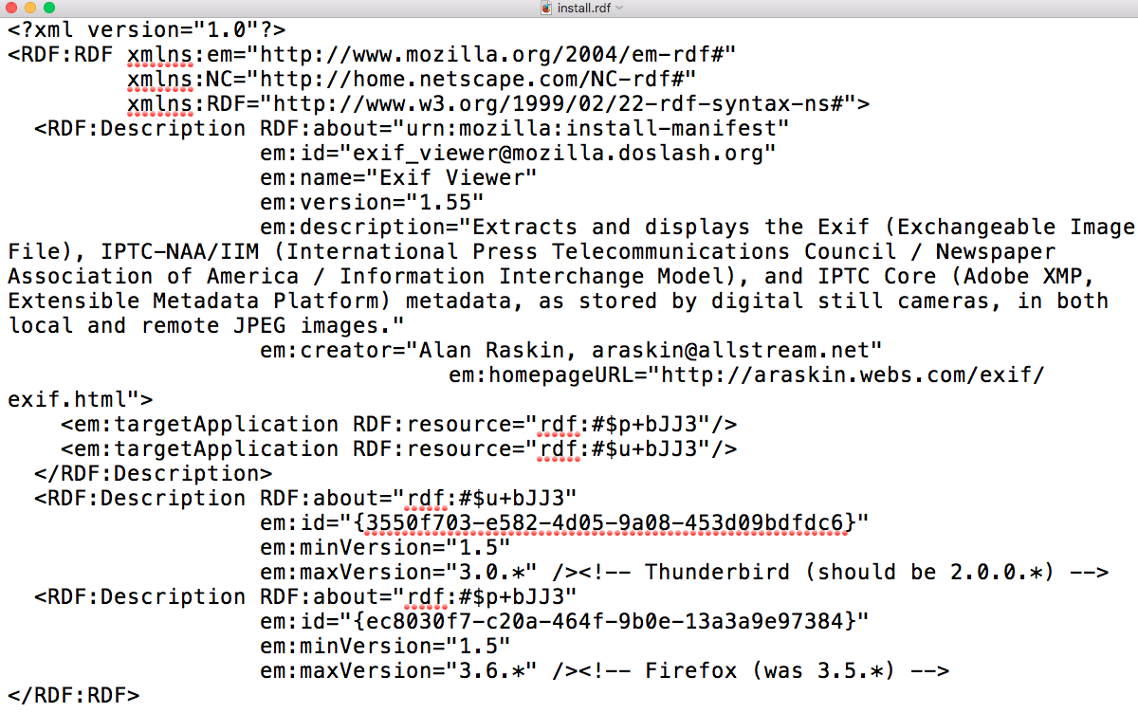

Figure-3: “install.rdf” content.

We speculated the user who used this exif.exe application wanted to obtain metadata information from a still camera image. The metadata information might contain camera and picture setting including GPS information.

**With File: 06**

Result for file 06: We were able to identify this file to be a DMG file for the Mac. See table below:

|  |  |  |  |
| --- | --- | --- | --- |
| Tools | File type | header | Footer/trailer |
| FTK Imager | DMG | At top get this:78 01 63 60  found this at : 3C 3F 78 6D 6C 20 76 65 72 73 69 6F 6E 3D 22 31 2E 30 22 3F 3E  *Gary Kessler Signature File Table:*  -78 01 73 0D 62 62 60 is DMG;  -3C 3F 78 6D 6C 20 76 65 72 73 69 6F 6E 3D 22 31 2E 30 22 3F 3E is XML | No footer |
| HexEdit | DMG | Got:78 01 63 60  *Gary Kessler Signature File Table:*  3C 3F 78 01 73 0D 62 62 60 | No footer |
| TrID:  Marco Pontello  marcopon@gmail.com | 50% DMG  50% XMI | Disk Image (Macintosh) compressed XML  XMill is an efficient XML data compressor | N/A |
| Exiftool | Unknown file type | N/A | N/A |

Tracing through HexEdit on row e92f0, we found xml information pertaining to the Apple ‘XML property list’ which was explained from this link *http://newosxbook.com/DMG.html*. To confirm, we renamed the 06 file to ’06.dmg’ and opened it from a Macintosh. This dmg package contained ‘*Hex Fiend.app’*.

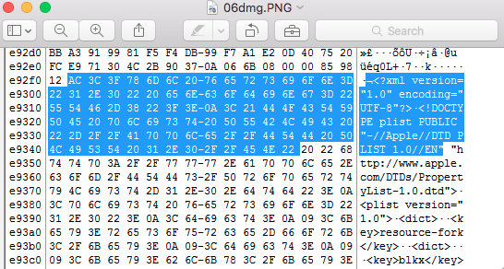

Figure 4: *06.dmg*

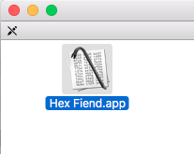

Figure-5: *06.dmg content*

This Hex Fiend.app was a hex editor application for a Macintosh.

**With File: 07**

Result for 07 file: we were able to identify this file to be a RPM file that was a Red Hat Linux Package Manager file. See table below:

|  |  |  |  |
| --- | --- | --- | --- |
| Tools | File type | header | Footer/trailer |
| FTK Imager | HTTP | 68 74 74 70 | No footer |
| HexEdit | HTTP | 68 74 74 70 | No footer |
| TrID: | 100% RPM Package generic | RedHat Package Manager file since seeing several files nested inside from reading the hex | N/A |
| Exiftool | Unknown file type | N/A | N/A |

To confirm this 07 file, we opened 07 file on Kali and confirmed it was RPM file. This file package contained directories of \etc, \usr and \var, (see figure 6 below), where each of these folders contained further nested directories for Apache server files.

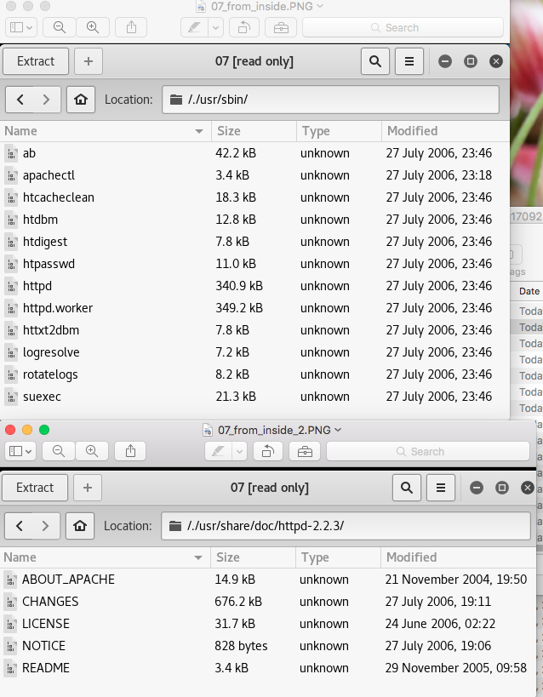

Figure-6: *07.rpm content*

**With File: 08**

Result for 08 file: we were able to identify this file to be a CHM file from Microsoft Compiled HTML.

See table below:

|  |  |  |  |
| --- | --- | --- | --- |
| Tools | File type | header | Footer/trailer |
| FTK Imager | ITSF | 49 54 53 46  *Gary Kessler Signature File Table:*  Microsoft Compiled HTML Help File | No footer |
| HexEdit | ITSF | 49 54 53 46  *Gary Kessler Signature File Table:*  Microsoft Compiled HTML Help File | No footer |
| TrID:  Davide “Airex” Airaghi  airex”AT”Tiscali”DOT”.it | 100% CHM file | Microsoft Compiled HTML Help File | No footer |
| Exiftool  Language code: English (U.S.) | CHM | N/A | N/A |

To confirm, we downloaded CHM viewer and able to see that ’*08’* file was a chm file for Nvidia Control Panel informaton.

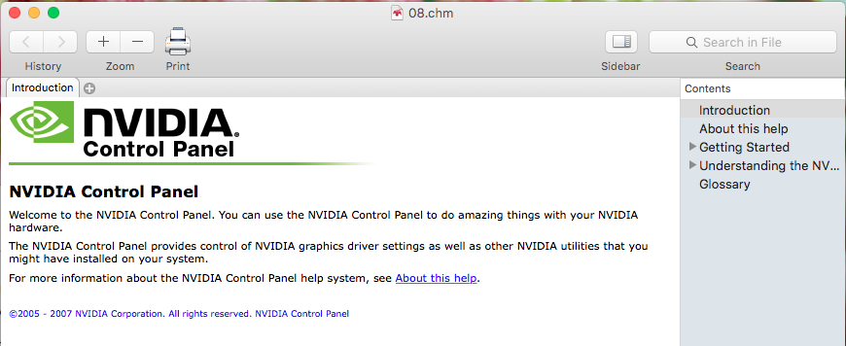

Figure-7: *08.chm content*

**With File: 09**

Result for 09 file: we were able to identify this file to be a MIDI file from FTK Imager, HexEdit and TrID.

To confirm, we renamed 09 file to *’09.mid’* and able to play the music. It was a MIDI sound file.

|  |  |  |  |
| --- | --- | --- | --- |
| Tools | File type | header | Footer/trailer |
| FTK Imager | MThd  MIDI | 4D 54 68 64  *Gary Kessler Signature File Table:*  Musical Instrument Digital Interface (MIDI) sound file | No footer |
| HexEdit | MThd  MIDI | 49 54 53 46  *Gary Kessler Signature File Table:*  Musical Instrument Digital Interface (MIDI) sound file | No footer |
| TrID: | 100% MIDI | MIDI Music  URL: www.midi.org | No footer |
| exiftool | Unknown file type | N/A | N/A |

**With File: 10**

Result for 10 file: we were able to identify this file to be a ReadMe file from FTK Imager and HexEdit. From Gary Kessler Signature File Table, there was no file type for *‘.txt’*. With FTK Imager mode set to hex view automatic, we were able to see a README file of Microsoft File Checksum Integrity Verifier V2.05. See table below:

|  |  |  |  |
| --- | --- | --- | --- |
|  | File type | header | Footer/trailer |
| FTK Imager | A readme file from Microsoft File Checksum Integrity | 4D 69 63 72 6F 73 6F 66  Microsoft (R) File Checksum Integrity Verifier V2.05 README file  *Gary Kessler Signature File Table:*  Microsoft type of file when have these 4D 69 63 72 as the 4 bytes | No footer |
| HexEdit | A readme file from Microsoft File Checksum Integrity | 4D 69 63 72 6F 73 6F 66  Microsoft (R) File Checksum Integrity Verifier V2.05 README file  *Gary Kessler Signature File Table:*  Microsoft type of file when have these 4D 69 63 72 as the 4 bytes | No footer |
| TrID: | 0.0% matched | N/A | N/A |
| exiftool | Unknown file type | N/A | N/A |

To confirm, we renamed 10 file to ’10.txt’ and opened it. It was a ReadMe file for File Checksum Integrity Verifier. But we tried to rename to 10 file to *’10.doc’* or *’10.docx’* and was not able to open the file.

**With File: 11**

Result for 11 file: we were able to identify this file to be a Microsoft Word doc file from TrID and Exiftool. With FTK Imager mode set to hex-viewer to text, we were able to see the information about ‘*Robocopy is a 32 bit command-line tool’* information. Also when we renamed the 11 file to *‘11.doc’* and it opened up as a windows word doc. It was a user manual of Robocopy.exe (Robust File Copy Utility version XP010). See table below:

|  |  |  |  |
| --- | --- | --- | --- |
| Tools | File type | header | Footer/trailer |
| FTK Imager | OLE | D0 CF 11 E0 A1 B1 1A E1  *Gary Kessler Signature File Table:*  An Object Linking and Embedding  (OLE) format known as Compound Binary File format by Microsoft used by Microsoft Office | No footer |
| HexEdit | OLE | D0 CF 11 E0 A1 B1 1A E1  *Gary Kessler Signature File Table:*  An Object Linking and Embedding (OLE) format known as Compound Binary File format by Microsoft used by Microsoft Office | No footer |
| TrID: | 36% DOC  33.7 % XLS  21.3% DOC  9% | Microsoft Word Doc  Microsoft Excel sheet  Microsoft Word doc (old ver)  Generic OLE2/Multistream Compound File | No footer |
| Exiftool | DOC | N/A | N/A |

**With File: 12**

Result for 12 file: we were able to identify this file to be a Bit Torrent file from TrID and Exiftool. See table below:

|  |  |  |  |
| --- | --- | --- | --- |
| *Tools* | *File type* | *header* | *Footer/trailer* |
| FTK Imager | N/A | 64 38 3A 61 6E 6E 6F 75  Gary Kessler has no info with this header decimal value | N/A |
| HexEdit | N/A | 64 38 3A 61 6E 6E 6F 75  Gary Kessler has no info with this header decimal value | N/A |
| TrID: | 57.7% TORRENT  42.3%  TORRENT | Bit Torrent Link (Trackerless)  Bit Torrent Link | N/A |
| ExifTool | Torrent | Note: file extension: torrent | N/A |

From FTK Imager and HexEdit, we found these info:

d8:announce39:http://torrent.ubuntu.com:6969/announce13:announce-listll39:http://torrent.ubuntu.com:6969/announceel44:http://ipv6.torrent.ubuntu.com:6969/announceee7:comment29:Ubuntu CD releases.ubuntu.com13:creation datei1256817676e4:infod6:lengthi724353024e4:name29:ubuntu-9.10-desktop-amd64.iso12:piece lengthi524288e6:pieces27640:l

Ubunte CD release from 2009 name29:ubuntu-9.10-desktop-amd64.iso

# Exercise 3 – Anti Forensics

**Objective:** Acquire data by acquisition to ensure the integrity of evidence is read-only prior to analyzing the data.

**Evidences:** To acquire the c.mp3 and Suspicious\_File evidence files by using file carving technique to investigate what these two files really are.

**Chain-of-custody**: generated hash values for all evidence acquired from tools.

**Tools used:** EnCase version 8.04,AccessData FTK Imager version 3.4.2.6, GpgEX part of Gpgwinversion 3.0.0, Elcomsoft Forensic Disk Decryptor version 1.12.324.3299, HexEdit version 4.0, Scalpel, Foremost, TrID version 1.80, Exiftool version 10.6.1.0, Malwaretracker.com and Virustotal.com.

Note: EnCase, Scalpel and Foremost automatically performed the file carving on these two evidence files.

1. **Acquisition:** c.pm3

**How did you proceed your examination and analysis of the files? Describe methodology and your results**

From Kali(linux), commands used for c.mp3 file

* scalpel –o /root/Desktop/ex3\_mp3/test –v /root/Desktop/c.mp3
* Resulted with extraction of c.mp3 file into one JPG and three of PGP files. See appendix 1(c.mp3).
* 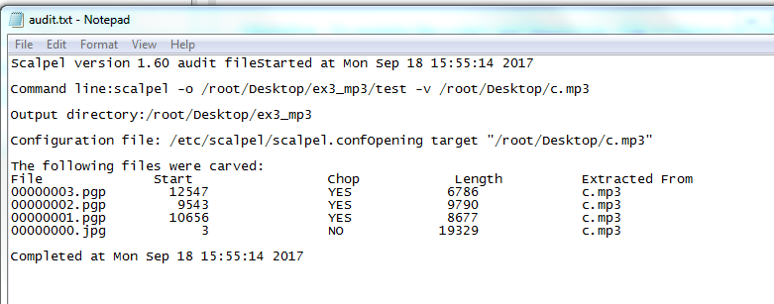Figure-8: Summary Scalpel report on c.mp3 file.
* The 00000000.jpg file was a picture of Keira Knightley. See figure-9 below.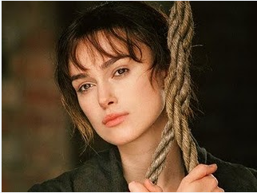
* Figure-9: Result of 00000000.jpg file.
* With three PGP files, we were not able to decrypt using this GpgEX tool.
* PGP files not able to decrypt because GpgEX tool required a key to decrypt a pgp file.
* Foremost tool on Kali:
* Foremost -o /root/Desktop/ex3\_mp3/test –i /root/Desktop/c.mp3
* Extraction result was only one file. It was a 00000000.jpg file. Opening this extracted 0000000.jpg file revealed it was the same picture as from scalpel extracted 0000000.jpg file.

**Analysis:**

1. Windows: we used HexEdit and TrID to analyze further this c.mp3. It appeared to be that the c.mp3 file header has been modified with ’49 44 33’ to hide the real file type which was JFIF. But according to TrID, it reported 100% matching to mp3 file.

|  |  |  |  |
| --- | --- | --- | --- |
| *Tools* | *File type* | *header* | *Footer/trailer* |
| HexEdit | JFIF | 49 44 33 FF D8 FF E0 00 10 4A 46 49 46 49 46 00  ‘4A 46 49 46’ = JFIF  Gary:   |  |  |  | | --- | --- | --- | | FF D8 FF E0 xx xx 4A 46 49 46 00 |  | ÿØÿà..JF IF. | | JFIF, JPE, JPEG, JPG |  | [JPEG/JFIF graphics file](http://www.jpeg.org/public/jfif.pdf" \t "_blank) | | FF D9 |
| FTK Imager | No data found | N/A | N/A |
| ExifTool | File Format Error | N/A | N/A |
| TrID: | 100% matching MP3 | Note: not a real mp3 file  49 44 33 : only read the 3 bytes from header info and assume it is mp3 | N/A |

Malwaretracker.com/doc.php was used to analyze further of c.mp3 file:

Md5: 670a8c0db494ced4882e44b27dbd6af2

Sha1: c5e6e5e1715e90879829264c88ad83160bbe358c

Sha256:

Content/type: audio ID3 type verion 2.255.216

Analysis time: 5.2s

Result: clean

Virustotal.com was used to analyze further of c.mp3 file:

Md5: 670a8c0db494ced4882e44b27dbd6af2

Sha1: c5e6e5e1715e90879829264c88ad83160bbe358c

FileType: MP3

ID3Size 0

MIMETYPE audio/mpeg

Warning: invalid ID3 header

**Summary** of c.mp3 file:

**Could you identify the files? If so, what type of files were they? Could you find anything peculiar about the files?**

It appeared to be an image JPEG file but not a mp3 file. Based on the Virustotal.com warning message, the invalid ID3 header confirmed with HexEdit that the first 3 bytes of header information were modified to be a mp3 file to hide the real purpose of this JPEG file. Also, the extension was modified to *‘.mp3’* instead of *‘.jpg’*.

**II) Acquisition:**  Suspicious\_File

**How did you proceed your examination and analysis of the files? Describe methodology and your results.**

1. Scalpel from Kali(linux) commands was used for Suspicious\_File file:

* scalpel –o /root/Desktop/ex3\_mp3/test –v /root/Desktop/ Suspicious\_File

Resulted with extraction of Suspicious\_File file into 687 files where two files (00000000.doc and 00000001.doc) were doc files and the rest were PGP files. See appendix 2 (Suspicious\_File).

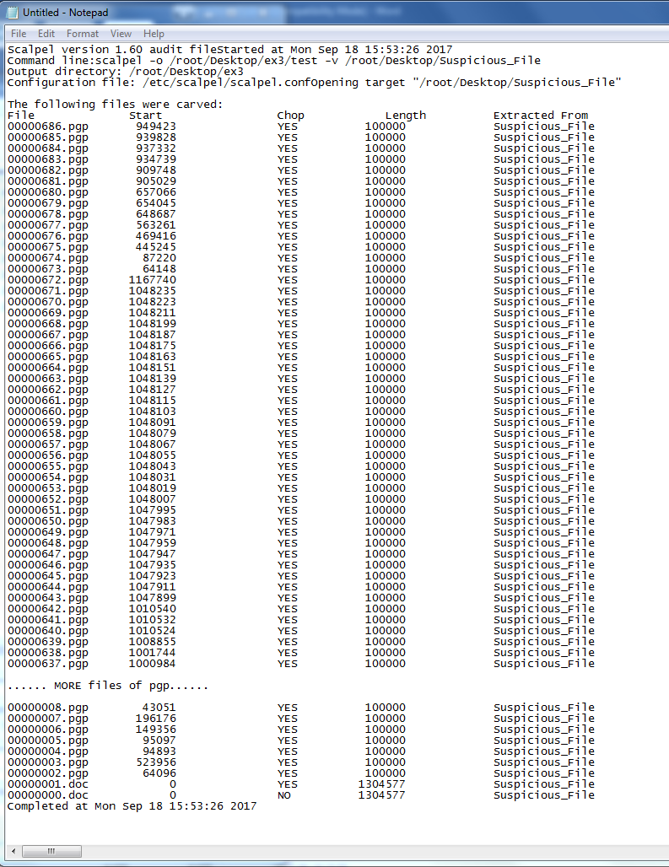

Figure-10: Scalpel results.

* With PGP files, we downloaded Elcomsoft Forensic Disk Decryptor to try to decrypt PGP files. But this tool also asked for the keys to these PGP files in order to decrypt them. We could not process further.
* Foremost tool on Kali:

> foremost –i /root/Desktop/ex3/Suspicious\_file –o /root/Desktop/test

* Foremost extracted into one OLE file (00000000.ole).
* EnCase on Windows 7:

Using EnCase, we were able to file carve Suspicious\_File and discovered there were two files wrapped inside the Suspicious\_File. These two files were ‘Details’ and ‘File\_0’. See figure-11 below:

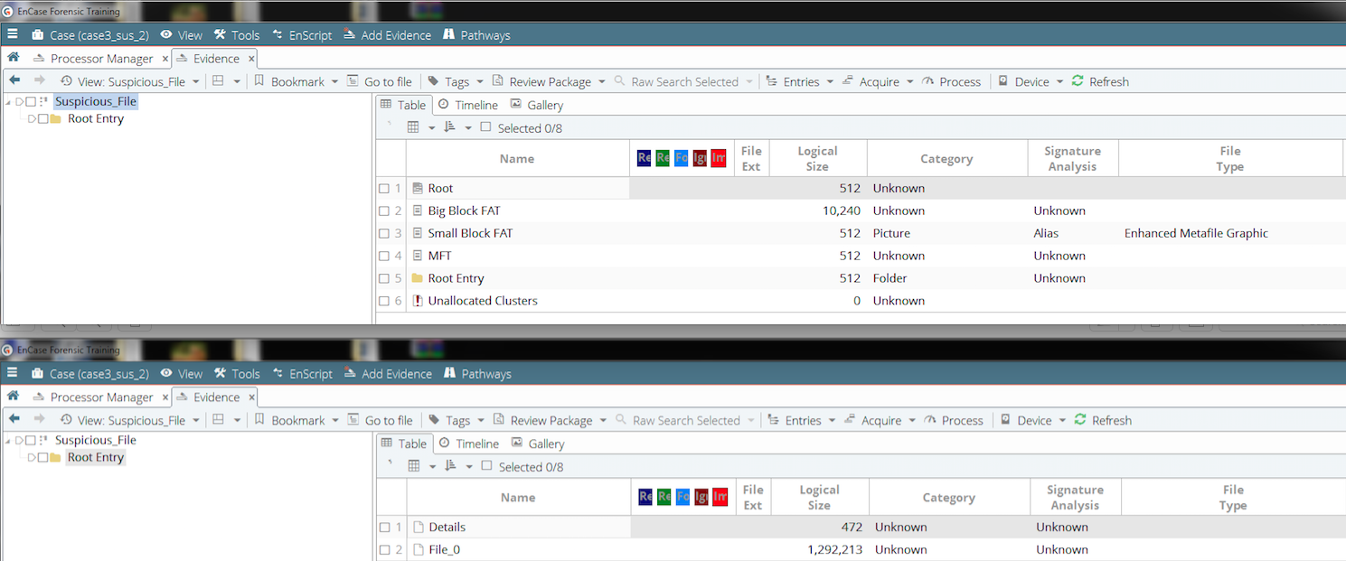

Figure-11: EnCase result.

**Analysis:** Suspicious\_File

|  |  |  |  |
| --- | --- | --- | --- |
| *Tools* | *File type* | *header* | *Footer/trailer* |
| FTK | OLECF | D0 CF 11 E0 A1 B1 1A E1  *Gary Kessler Signature File Table:*  According to Gary Kessler, it was an OLECF file. | N/A |
| HexEdit | OLECF | D0 CF 11 E0 A1 B1 1A E1  *Gary Kessler Signature File Table:*  According to Gary Kessler, it was an OLECF file. | N/A |
| TrID: | 100% OLE2 | Generic OLE2 Multistream Compound File | N/A |
| Exiftool | N/A | N/A | N/A |

**Malwaretracker.com**/doc.php site redirected us to this Cryptam.com for analysis of Suspicious\_File, see figure-12 below:

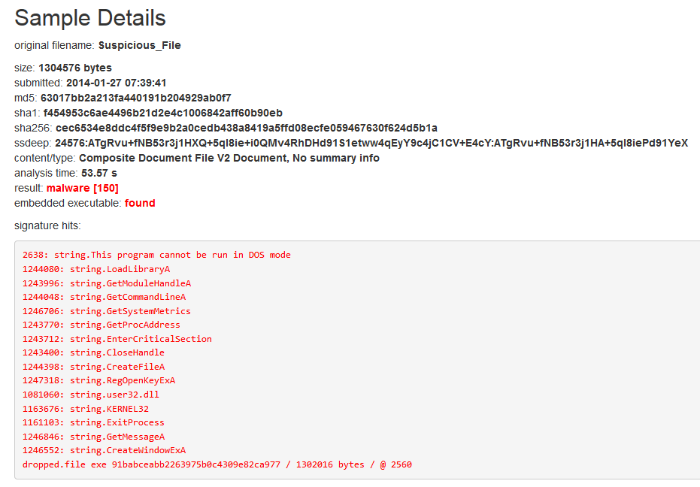

Figure-12: Malwaretracker results.

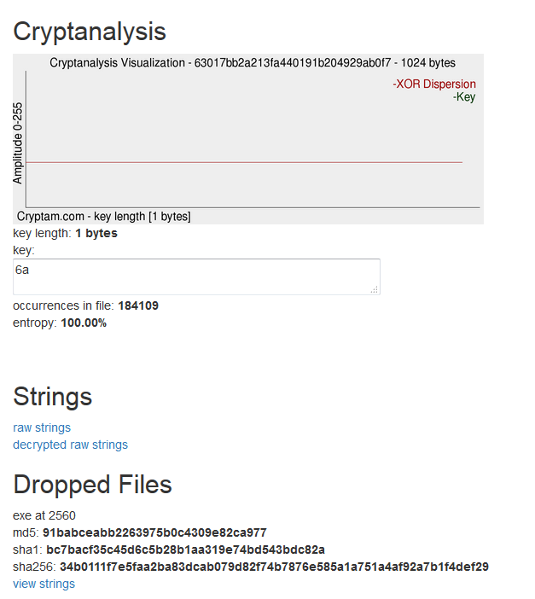

Figure-13: Key generated from Cryptam.com to decrypt the hex.

According to Malwaretracker.com analysis of the Suspicious\_File, it identified 150 malwares, see figure-12. It also had identified some strings that looked like function calls from a program and identified a *‘dropped.file exe’* program. We also noticed this *‘dropped.file exe’* had it’s own hash value from Malwaretracker. While analyzing the output from Cryptanalysis section (see figure-13), a key value was found ‘6a’. We speculated that this key value was used to decrypt the raw string data presented by Malwaretracker of *‘dropped.file exe’.* When accessing this link ‘decrypted raw strings’ option, we noticed these peculiarities:

* It revealed that there were several files with the word ‘copyright’ such as:

*- Copyright (C) 1998, Thomas G. Lane*

*- deflate 1.1.3 Copyright 1995-1998 Jean-loup Gailly*

*- inflate 1.1.3 Copyright 1995-1998 Mark Adler*

*- Copyright (c) 1992-2001 by P.J. Plauger, licensed by Dinkumware, Ltd. ALL RIGHTS RESERVED.*

*- Copyright 2003 - 2004 PopCap Games, Inc.*

* Additionally, we found these URL of:

*- http://www.popcap.com/win32updatecheck2.php?prod=*

*- http://www.popcap.com/register.php?theGame=*

*- http://www.microsoft.com/directx*

*- http://www.popcap.com/beta\_validate.php?prod=*

*- http://store.gamehouse.com/buyzuma.jsp?AID=%AFFIL%&amp;D=%DAYS%&amp;M=%MINUTES%*

* And these information:
* *OriginalFilename*
* *Zuma.exe*
* *ProductName*
* *Zuma Deluxe*
* *ProductVersion*
* *1.0.0.1*
* *SpecialBuild*
* *Presented by GameHouse*
* We also discovered there were random information such as:
* *TimeZoneName=Arab Standard Time*
* *Names of months but May, June and July months were missing*
* *Names of days*
* *Instructions*
* *names of players and characters*
* *names of sounds files*
* *names of image files and many more…..*

**Virustotal.com**:

According to Virustotal.com, we were able to obtain similar information as EnCase because both tools identified two files, Details and File\_0, see figure-14 below.

Virustotal.com identified these information from the *Detection* info tab:

*Generic OLE2 Multistream Compound File*

*Detection: CAT-QuickHeal: OLE.Win32.Agent.EB*

*NANO-Antivirus: Virus.Win32.Gen.ccmw*

From *Details* tab:

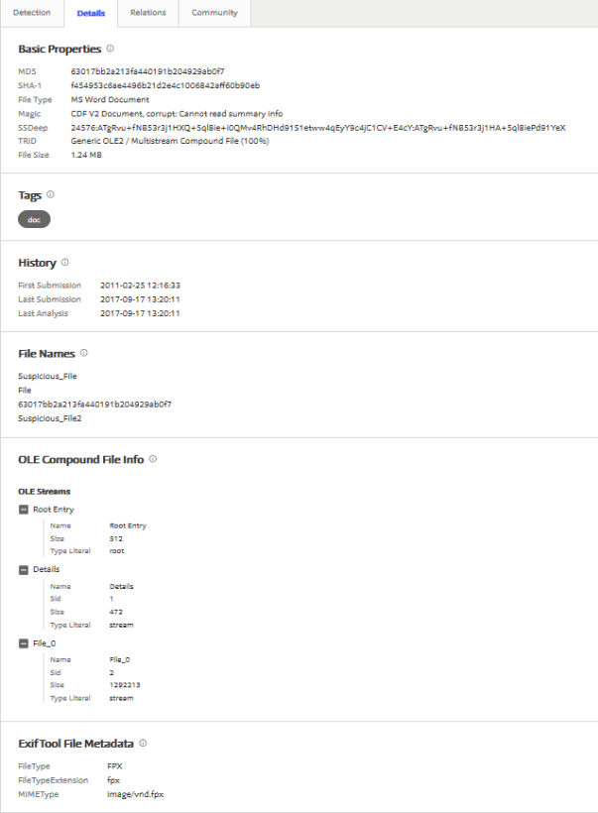

Figure-14: Virustotal.com results

We speculated what VirusTotal had detected two types of viruses are: *‘OLE.Win32.Agent.EB’* and *‘Virus.Win32.Gen.ccmw’* . Additionally, it had identified two files that were similarly named as EnCase results and they were *‘Details’* and *‘File\_0’,* see figure-14.

**Summary** of Suspicious\_File:

**Could you identify the files? If so, what type of files were they? Could you find anything peculiar about the files?**

We were not really able to identify Suspicious\_File because it appeared to contain multiple files that were wrapped into one large file. We were able to carve the files by using Scalpel, Foremost and EnCase. Only Scalpel tool able to carve out 687 files (see appendix-2) where Foremost carved only one file out and EnCase carved two files out. Also we speculated that there could be two viruses stored in the Suspicious\_File based on the findings from Virustotal.com and Malwaretracker.com. See Analysis section above regarding the peculiarities found.

# Exercise 4 - Acquisition

See *DIFO2017\_Lab1\_Report\_Group14\_Ex4.pdf* for answer to Exercise 4.

# Exercise 5 - Cracking

**Objective:** To crack the protected and or encrypted files by using brute force technique.

**Evidences:** Unnamed 1.xls, casssh.pdf, Untitles.docx, hr.gpg.tar and wallet.dat

**Chain-of-custody**: Used md5 and sha256 algorithm to hash the evidence files.

**Tools used:** hashcat version 3.6.0, AccessData PRTK version 8.1.0 build 946 and sha256deep64.exe

**Acquisition**: The steps to acquire the evidence files used are:

1. Md5deep64.exe and sha256deep64.exe to generate md5 hash values:

|  |  |  |
| --- | --- | --- |
| Name | MD5 | SHA256 |
| **casssh.pdf** | f77f0c2ea19035ace1d47b266245984d | a5ba8562717a9c128bdb87d3b0b327cea7bb24f33fd599d5de8fc6d41c174d02 |
| **ht.zip.tar.gpg** | 159ef8f471caef32db49dc9b331e10a5 | 2fe1cd6a80f6609efbc4fc142ce552ef46155f0fe1b0b765f0b12ea7fd5d8f8b |
| **untitled.docx** | 3a9b988f1496b2598cf08023603bcf3c | c28739a4507ca3f39ac0cf1a06de6f58d410b3a1fb8724268264d1cbe67e8112 |
| **wallet1.dat** | fbf3b26fcf8e9fe4ec2e70175255e36c | 6c073f77c40ca84a1ada73452633b58359d055e37ae75dcec0f663538db859a5 |
| **Untitled 1.ods** | 0a4532f87c41c31f1b716cd21ea8fa51 | 126b46eb0c3891f86f38af95b810ed083f242e5aaaa5bbd84caf9f1ee28af6a3 |

1. To ensure that we didn’t alter these five evidence files, we used the copied of the evidence files to crack the passwords on these files.

***1) Casssh.pdf***: We used dictionary brute force attack with this evidence file using ‘Access Data Password Recovery Toolkit (PRTK)’ tool.

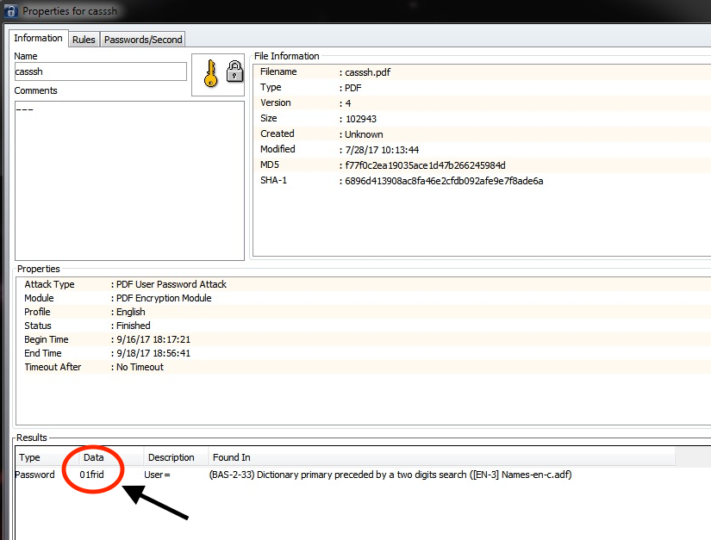

Figure-15: Password for pdf file

It tooks about 8 hours to crack this casssh.pdf and two days to verify the password. The password was ‘01frid’ for this *‘casssh.pdf’* file. By using this password, we were able to open *‘casssh.pdf’* file and the result was:



Figure-16: Result of casssh.pdf.

***2) ht.zip.tar.gpg:*** We started the password cracking process on 2017-09-18 14:38:10 using ‘Access Data Password Recovery Toolkit (PRTK)’ and

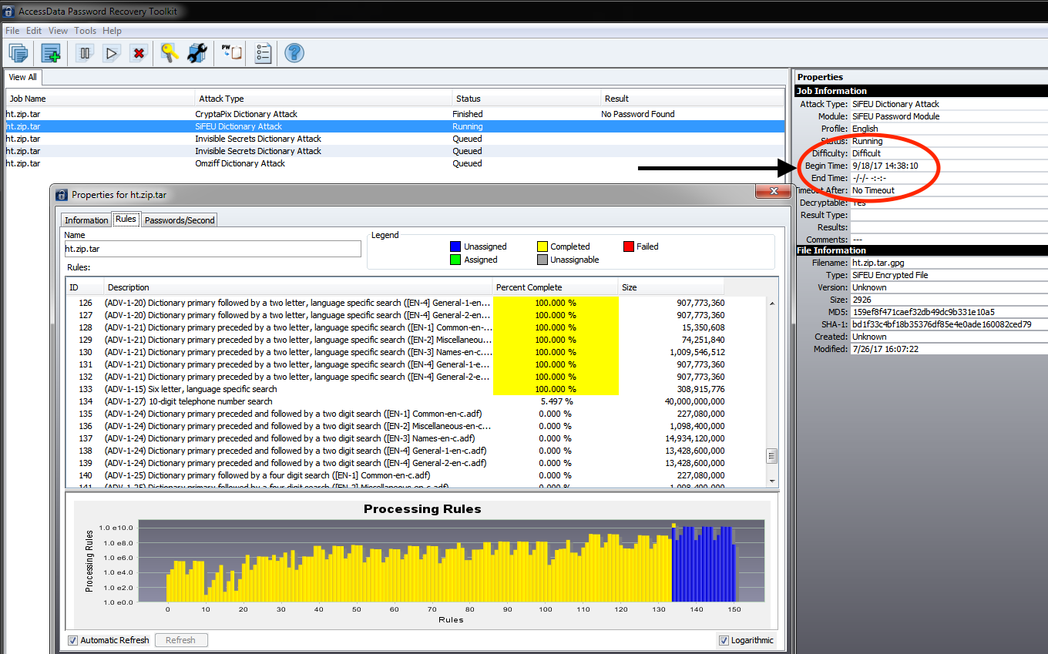

Figure-17: Result of “***ht.zip.tar.gpg***”

we were not able to complete this file due to taking too long to crack. The reasons were: it had multiple Attack type rule policies that were needed to be processed to crack the password on this file, see figure-17 above.

We could crack with one of the Attack Type rule policy and the result was ‘no password found’ (see figure 18 below) and other Attack type rule policies continued to process which had taken more than two weeks to process.

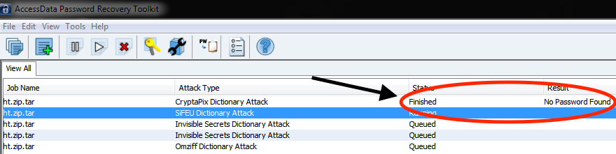

Figure-18: Finished with one file rule policy

***3) Untitled 1.ods, untitled.docx:***

We used ‘Access Data Password Recovery Toolkit (PRTK)’ to crack *‘Untitled 1.ods’* and *‘untitled.docx’* files. These files also have been running more than two weeks similar to file ‘*ht.zip.tar.gpg’* procedureabove and still it has been continuing to process. We were not able to complete these files for password cracking due to limited time resource.

***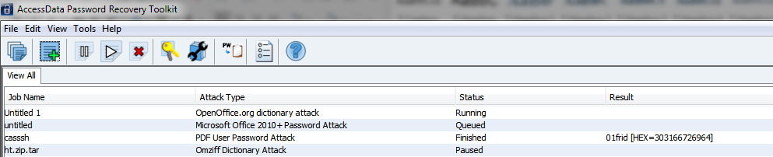***

Figure 19: Result of ***Untitled 1.ods, untitled.docx:***

1. ***wallet1.dat:*** We used ‘Access Data Password Recovery Toolkit (PRTK)’ to crack *‘wallet1.dat’* and an error message had occurred. The error was “Unable to identify file type for decryption”, see figure-20.

***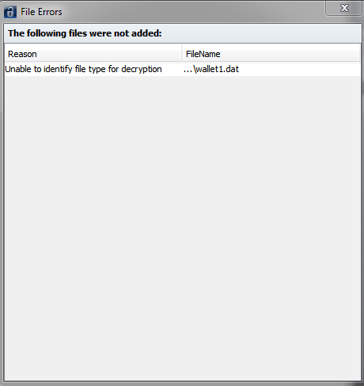***

Figure 20: Result of ***wallet1.dat***

**5)** We used PWD2 (10.11.200.152) machine as well to crack this file *‘casssh.pdf’* by using Hashcat tool. Command used were:

*>C:\Users\group 14\Desktop\hashcat-3.6.0>hashcat64 -m 10500 -a 3 "C:\Users\group 14\Desktop\Exercise5\_Cracking\casssh\_hash"*

Also, we tried to crack other evidence files such as ‘*ht.zip.tar.gpg’* using Hashcat on the PWD2 server and it took too long because we were limited with time resource on this server. The other evidence files were not executed using Hashcat.

# Exercise 6 - Steganography

**Objective:** To find any hidden data from the two evidence (*c1l.png* and *c2l.png*) files given.

**Evidences:** *c1l.png* and *c2l.png*

**Chain-of-custody**: generated hash values using md5deep64.exe.

**Tools used:** Exiftool version 10.6.1.0, md5deep64 version 4.4, TweakPNG version 1.4.6, Rizzy.py and Stepic-0.3.

**Identify the two files, what they do depict?**

From visual inspection, these two files (*c1l.png and c2l.png*) depicted CS2 in large black block letters and with smaller blue text of Cyber Systems Security Laboratory on the right side of CS2. See figure 21.

**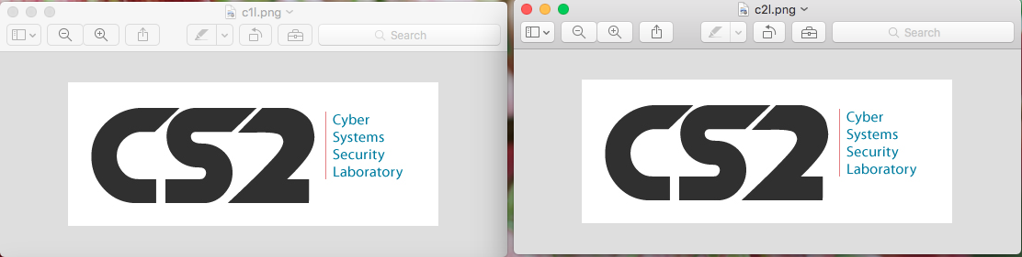**

Figure 21: Visual inspection of evidence files.

From the visual inspection, there seen to be no differences between these two files so far.

**What are their hash sums?**

The hash algorithm used was md5 on both *c1l.png* and *c2l.png* files.

- *c1l.png* hash value: 601450fd443v42f4ece0e3f001ed73b3

- *c2l.png* hash value: b914cc2043a6d5b31ff4bb6f5f1291fc

After we generated the hash values for these two files, we realized there could be differences between these two files since the hash values provided by md5deep64.exe were different.

**What are their META data?**

Using Exiftool, it identified these two files as unique files because we noticed that *c2l.png* didn’t have information of *Significant Bits, Pixels Per Unit X, Pixels Per Unit Y, and Pixel Units*  such as the *c1l.png* file. See figure 22.

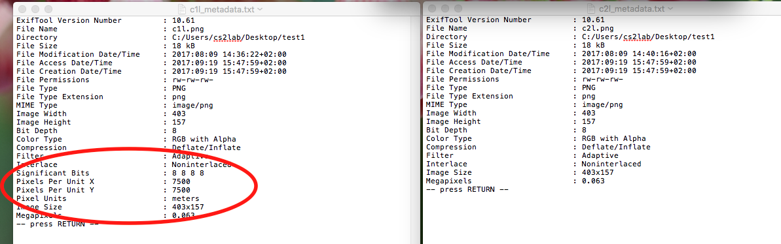

Figure 22: Metadata information of evidence files.

**Which tool/tools did you use to find out if there was any message in the image(s)?**

Tools used were: TweakPNG, Exiftool, md5deep64.exe, rizzy.py and stepic.py.

With TweakPNG.exe, it provided the critical chunks information of the evidence files such as IHDR, sBIT, pHYs, IDAT and IEND, See figure-23which led us to believe that there could be hidden message in one of the evidence file.

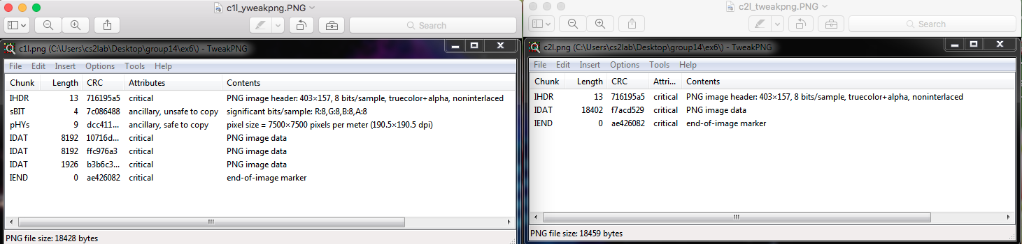

Figure 23: Critical chunks information of evidence files.

When using the Rizzy.py and stepic.py tools, both tools revealed a hidden message from *c2l.png* file which is *‘*[*http://xdsa5xcrrrxxxolc.onion/*](http://xdsa5xcrrrxxxolc.onion/)*’*. See figure 24:

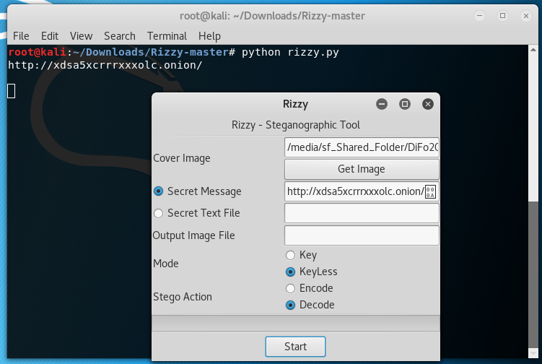

Figure-24: Rizzy.py found hidden message from *c2lp.png*.

Additionally, both rizzy.py and stepic.py tools found this *‘invalid UTF-8 string passed’* from *c1l.png.* See figure -25:

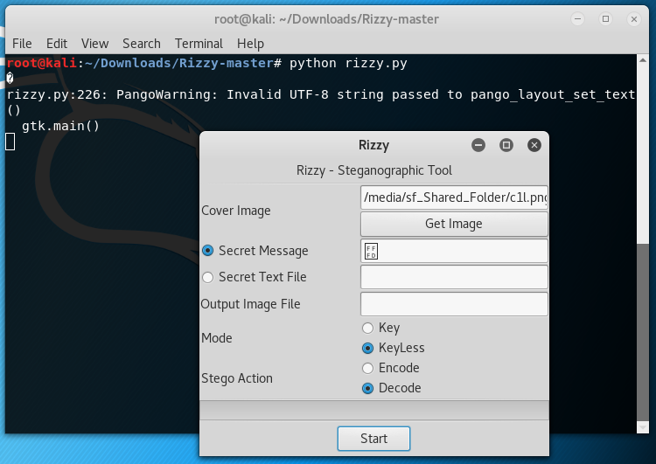

Figure-25: Rizzy.py found invalid UTF-8 message from *c1lp.png*.

**Analysis:**

**How was the message hidden in the image?**

We speculated that the hidden message was hidden inside the IDAT chunk in the *c2l.png* file. The reason how we derided to this conclusion was that we used rizzy.py to encrypt the hidden message of *‘*[*http://xdsa5xcrrrxxxolc.onion/*](http://xdsa5xcrrrxxxolc.onion/)*’* from *c2l.png* to *c1l.png*. The test output file *c1l\_encoded.png* also had the same critical chunks information like *c2l.png*. See figure-26 and compare to Figure-23.

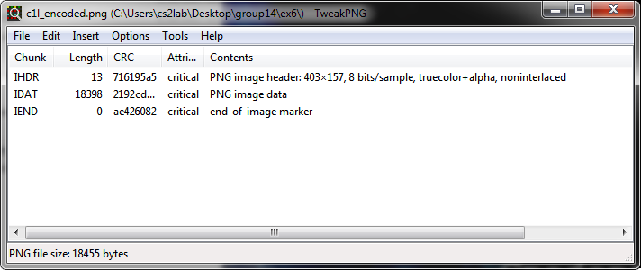

Figure 26: Critical chunks information of *c1l\_encoded.png.*

One could see that both *c2l.png* and *c1l\_encoded.png* files had the same critical chunks information, see Table-1 below. This confirmed our theory that *c2l.png* had been altered to contain a hidden message and that *c1l.png* was the source for *c2l.png* file. Due to this confirmation test, it allowed us to be able to perform a comparison test.

Table-1: PNG critical chunks information

|  |  |  |  |
| --- | --- | --- | --- |
| **Critical Chunks** | c1l.png | c2l.png | c1l\_encoded.png (a test file) |
| **IHDR** | Yes | No | No |
| **IDAT** | Found 3 chunks | Only 1 IDAT found | Only 1 IDAT |
| **sBit** | Yes | No | No |
| **pHYs** | Yes | No | No |
| **IEND** | Yes | Yes | Yes |
| **Hidden message** | Invalid of UTF-8 string | <http://xdsa5xcrrrxxxolc.onion/> | <http://xdsa5xcrrrxxxolc.onion/> |

By looking at these critical chunks information, it led us to experiment with another png file (*jaguar.png*) which we downloaded from the internet. We wanted to confirm what a regular png file would have for the critical chunks information so that we could confidently conclude if the *c1l.png* file was an original file and it hadn’t been altered in anyway.

By using the *jaguar.png*, we discovered that it did contain the same critical chunks information like *c1l.png* file except that the *jaguar.png* had more IDAT chunks. The extra IDAT chunks might meant that the *jaguar.png* contained more image data than *c1l.png* file. When we encoded the same hidden message from *c2l.png* into *jaguar.png* file, it also revealed that the critical chunks information were same as *c2l.png* file, see Table-2 below.

Table-2: PNG critical chunk information

|  |  |  |  |  |  |
| --- | --- | --- | --- | --- | --- |
| **Critical Chunks** | c1l.png | c2l.png | c1l\_encoded.png  (a test file) | jaguar.png | jaguar\_encoded.png (a test file) |
| **IHDR** | Yes | No | No | Yes | No |
| **IDAT** | Found 3 chunks | Only 1 IDAT found | Only 1 IDAT | 38 IDAT found | 9 IDAT found |
| **sBit** | Yes | No | No | Yes | No |
| **pHYs** | Yes | No | No | Yes | No |
| **IEND** | Yes | Yes | Yes | Yes | No |
| **Hidden message** | Invalid of UTF-8 string | <http://xdsa5xcrrrxxxolc.onion/> | <http://xdsa5xcrrrxxxolc.onion/> | Invalid of UTF-8 string | <http://xdsa5xcrrrxxxolc.onion/> |

**Could you have found the message in any other way?**

Maybe HexExit tool can be used as an alternative tool to find hidden messages in c2l.png file.

Appendix 1: c.mp3

root@kali:~/Desktop/test# scalpel -o /root/Desktop/test/output\_mp3/ -v /root/Desktop/test/c.mp3

Scalpel version 1.60

Written by Golden G. Richard III, based on Foremost 0.69.

Output directory: "/root/Desktop/test/output\_mp3"

Configuration file: "/etc/scalpel/scalpel.conf"

Coverage maps directory: "/root/Desktop/test/output\_mp3"

Opening target "/root/Desktop/test/c.mp3"

Total file size is 19332 bytes

Image file pass 1/2.

Read 19332 bytes from image file.

/root/Desktop/test/c.mp3: 100.0% |\*\*\*\*\*\*\*\*\*\*\*\*\*\*\*\*\*\*\*\*\*\*| 18.9 KB 00:00 ETAA jpg header was found at : 3

Memory reallocation performed, total header storage = 101

A jpg footer was found at : 19330

Memory reallocation performed, total footer storage = 101

A pgp header was found at : 10656

Memory reallocation performed, total header storage = 101

A pgp header was found at : 9543

Memory reallocation performed, total header storage = 101

A pgp header was found at : 12547

Allocating work queues...

Work queues allocation complete. Building carve lists...

Carve lists built. Workload:

art with header "\x4a\x47\x04\x0e" and footer "\xcf\xc7\xcb" --> 0 files

art with header "\x4a\x47\x03\x0e" and footer "\xd0\xcb\x00\x00" --> 0 files

gif with header "\x47\x49\x46\x38\x37\x61" and footer "\x00\x3b" --> 0 files

gif with header "\x47\x49\x46\x38\x39\x61" and footer "\x00\x3b" --> 0 files

jpg with header "\xff\xd8\xff\xe0\x00\x10" and footer "\xff\xd9" --> 1 files

png with header "\x50\x4e\x47\x3f" and footer "\xff\xfc\xfd\xfe" --> 0 files

bmp with header "\x42\x4d\x3f\x3f\x00\x00\x00" and footer "" --> 0 files

tif with header "\x49\x49\x2a\x00" and footer "" --> 0 files

tif with header "\x4d\x4d\x00\x2a" and footer "" --> 0 files

avi with header "\x52\x49\x46\x46\x3f\x3f\x3f\x3f\x41\x56\x49" and footer "" --> 0 files

mov with header "\x3f\x3f\x3f\x3f\x6d\x6f\x6f\x76" and footer "" --> 0 files

mov with header "\x3f\x3f\x3f\x3f\x6d\x64\x61\x74" and footer "" --> 0 files

mov with header "\x3f\x3f\x3f\x3f\x77\x69\x64\x65\x76" and footer "" --> 0 files

mov with header "\x3f\x3f\x3f\x3f\x73\x6b\x69\x70" and footer "" --> 0 files

mov with header "\x3f\x3f\x3f\x3f\x66\x72\x65\x65" and footer "" --> 0 files

mov with header "\x3f\x3f\x3f\x3f\x69\x64\x73\x63" and footer "" --> 0 files

mov with header "\x3f\x3f\x3f\x3f\x70\x63\x6b\x67" and footer "" --> 0 files

mpg with header "\x00\x00\x01\xba" and footer "\x00\x00\x01\xb9" --> 0 files

mpg with header "\x00\x00\x01\xb3" and footer "\x00\x00\x01\xb7" --> 0 files

fws with header "\x46\x57\x53" and footer "" --> 0 files

doc with header "\xd0\xcf\x11\xe0\xa1\xb1\x1a\xe1\x00\x00" and footer "\xd0\xcf\x11\xe0\xa1\xb1\x1a\xe1\x00\x00" --> 0 files

doc with header "\xd0\xcf\x11\xe0\xa1\xb1" and footer "" --> 0 files

pst with header "\x21\x42\x4e\xa5\x6f\xb5\xa6" and footer "" --> 0 files

dbx with header "\xcf\xad\x12\xfe\xc5\xfd\x74\x6f" and footer "" --> 0 files

idx with header "\x4a\x4d\x46\x39" and footer "" --> 0 files

mbx with header "\x4a\x4d\x46\x36" and footer "" --> 0 files

wpc with header "\x3f\x57\x50\x43" and footer "" --> 0 files

htm with header "\x3c\x68\x74\x6d\x6c" and footer "\x3c\x2f\x68\x74\x6d\x6c\x3e" --> 0 files

pdf with header "\x25\x50\x44\x46" and footer "\x25\x45\x4f\x46\x0d" --> 0 files

pdf with header "\x25\x50\x44\x46" and footer "\x25\x45\x4f\x46\x0a" --> 0 files

mail with header "\x41\x4f\x4c\x56\x4d" and footer "" --> 0 files

pgd with header "\x50\x47\x50\x64\x4d\x41\x49\x4e\x60\x01" and footer "" --> 0 files

pgp with header "\x99\x00" and footer "" --> 1 files

pgp with header "\x95\x01" and footer "" --> 0 files

pgp with header "\x95\x00" and footer "" --> 2 files

pgp with header "\xa6\x00" and footer "" --> 0 files

txt with header "\x2d\x2d\x2d\x2d\x2d\x42\x45\x47\x49\x4e\x20\x50\x47\x50" and footer "" --> 0 files

rpm with header "\xed\xab" and footer "" --> 0 files

wav with header "\x52\x49\x46\x46\x3f\x3f\x3f\x3f\x57\x41\x56\x45" and footer "" --> 0 files

ra with header "\x2e\x72\x61\xfd" and footer "" --> 0 files

ra with header "\x2e\x52\x4d\x46" and footer "" --> 0 files

dat with header "\x72\x65\x67\x66" and footer "" --> 0 files

dat with header "\x43\x52\x45\x47" and footer "" --> 0 files

zip with header "\x50\x4b\x03\x04" and footer "\x3c\xac" --> 0 files

java with header "\xca\xfe\xba\xbe" and footer "" --> 0 files

max with header "\x56\x69\x47\x46\x6b\x1a\x00\x00\x00\x00" and footer "\x00\x00\x05\x80\x00\x00" --> 0 files

pins with header "\x50\x49\x4e\x53\x20\x34\x2e\x32\x30\x0d" and footer "" --> 0 files

Carving files from image.

Image file pass 2/2.

/root/Desktop/test/c.mp3: 100.0% |\*\*\*\*\*\*\*\*\*\*\*\*\*\*\*\*\*\*\*\*\*\*| 18.9 KB 00:00 ETAOPENING /root/Desktop/test/output\_mp3/pgp-34-0/00000003.pgp

CLOSING /root/Desktop/test/output\_mp3/pgp-34-0/00000003.pgp

OPENING /root/Desktop/test/output\_mp3/pgp-34-0/00000002.pgp

CLOSING /root/Desktop/test/output\_mp3/pgp-34-0/00000002.pgp

OPENING /root/Desktop/test/output\_mp3/pgp-32-0/00000001.pgp

CLOSING /root/Desktop/test/output\_mp3/pgp-32-0/00000001.pgp

OPENING /root/Desktop/test/output\_mp3/jpg-4-0/00000000.jpg

CLOSING /root/Desktop/test/output\_mp3/jpg-4-0/00000000.jpg

Processing of image file complete. Cleaning up...

Done.

Scalpel is done, files carved = 4, elapsed = 0 seconds.

Appendix 2: Suspicious\_File

1. edit the scalpel.conf file to so that would allow scalpel carve any file type.

root@kali:~# vi /etc/scalpel/scalpel.conf

root@kali:~# scalpel -o /root/Desktop/test -v /root/Desktop/test/Suspicious\_File

Scalpel version 1.60

Written by Golden G. Richard III, based on Foremost 0.69.

Output directory: "/root/Desktop/test"

Configuration file: "/etc/scalpel/scalpel.conf"

Coverage maps directory: "/root/Desktop/test"

1. root@kali:~# scalpel -o /root/Desktop/test/output/ -v /root/Desktop/test/Suspicious\_File

Scalpel version 1.60

Written by Golden G. Richard III, based on Foremost 0.69.

Output directory: "/root/Desktop/test/output"

Configuration file: "/etc/scalpel/scalpel.conf"

Coverage maps directory: "/root/Desktop/test/output"

Opening target "/root/Desktop/test/Suspicious\_File"

Total file size is 1304576 bytes

Image file pass 1/2.

Read 1304576 bytes from image file.

/root/Desktop/test/Suspicious\_File: 100.0% |\*\*\*\*\*\*\*\*\*\*\*\*| 1.2 MB 00:00 ETAA doc header was found at : 0

Memory reallocation performed, total header storage = 101

A doc footer was found at : 0

Memory reallocation performed, total footer storage = 101

A doc header was found at : 0

Memory reallocation performed, total header storage = 101

A pgp header was found at : 64096

Memory reallocation performed, total header storage = 101

A pgp header was found at : 523956

A pgp header was found at : 94893

Memory reallocation performed, total header storage = 101

A pgp header was found at : 95097

A pgp header was found at : 149356

A pgp header was found at : 196176

A pgp header was found at : 262143

A pgp header was found at : 856818

A pgp header was found at : 982885

A pgp header was found at : 1108369

A pgp header was found at : 1204055

A pgp header was found at : 1217347

A pgp header was found at : 1223699

A pgp header was found at : 1237111

A pgp header was found at : 1277062

A pgp header was found at : 18771

Memory reallocation performed, total header storage = 101

A pgp header was found at : 1048235

A pgp header was found at : 1167740

A pgp header was found at : 64148

Memory reallocation performed, total header storage = 101

A pgp header was found at : 87220

A pgp header was found at : 445245

A pgp header was found at : 469416

A pgp header was found at : 563261

A pgp header was found at : 648687

A pgp header was found at : 654045

A pgp header was found at : 657066

A pgp header was found at : 905029

A pgp header was found at : 909748

A pgp header was found at : 934739

A pgp header was found at : 937332

A pgp header was found at : 939828

A pgp header was found at : 949423

Allocating work queues...

Work queues allocation complete. Building carve lists...

Carve lists built. Workload:

art with header "\x4a\x47\x04\x0e" and footer "\xcf\xc7\xcb" --> 0 files

art with header "\x4a\x47\x03\x0e" and footer "\xd0\xcb\x00\x00" --> 0 files

gif with header "\x47\x49\x46\x38\x37\x61" and footer "\x00\x3b" --> 0 files

gif with header "\x47\x49\x46\x38\x39\x61" and footer "\x00\x3b" --> 0 files

jpg with header "\xff\xd8\xff\xe0\x00\x10" and footer "\xff\xd9" --> 0 files

png with header "\x50\x4e\x47\x3f" and footer "\xff\xfc\xfd\xfe" --> 0 files

bmp with header "\x42\x4d\x3f\x3f\x00\x00\x00" and footer "" --> 0 files

tif with header "\x49\x49\x2a\x00" and footer "" --> 0 files

tif with header "\x4d\x4d\x00\x2a" and footer "" --> 0 files

......(NOTE: we removed pgp files due to redundency).....

doc with header "\xd0\xcf\x11\xe0\xa1\xb1\x1a\xe1\x00\x00"

and footer "\xd0\xcf\x11\xe0\xa1\xb1\x1a\xe1\x00\x00" --> 1 files

doc with header "\xd0\xcf\x11\xe0\xa1\xb1" and footer "" --> 1 files

pst with header "\x21\x42\x4e\xa5\x6f\xb5\xa6" and footer "" --> 0 files

dbx with header "\xcf\xad\x12\xfe\xc5\xfd\x74\x6f" and footer "" --> 0 files

idx with header "\x4a\x4d\x46\x39" and footer "" --> 0 files

mbx with header "\x4a\x4d\x46\x36" and footer "" --> 0 files

wpc with header "\x3f\x57\x50\x43" and footer "" --> 0 files

htm with header "\x3c\x68\x74\x6d\x6c" and footer "\x3c\x2f\x68\x74\x6d\x6c\x3e" --> 0 files

pdf with header "\x25\x50\x44\x46" and footer "\x25\x45\x4f\x46\x0d" --> 0 files

pdf with header "\x25\x50\x44\x46" and footer "\x25\x45\x4f\x46\x0a" --> 0 files

mail with header "\x41\x4f\x4c\x56\x4d" and footer "" --> 0 files

pgd with header "\x50\x47\x50\x64\x4d\x41\x49\x4e\x60\x01" and footer "" --> 0 files

pgp with header "\x99\x00" and footer "" --> 2 files

pgp with header "\x95\x01" and footer "" --> 13 files

pgp with header "\x95\x00" and footer "" --> 656 files

pgp with header "\xa6\x00" and footer "" --> 14 files

txt with header "\x2d\x2d\x2d\x2d\x2d\x42\x45\x47\x49\x4e\x20\x50\x47\x50" and footer "" --> 0 files

rpm with header "\xed\xab" and footer "" --> 0 files

wav with header "\x52\x49\x46\x46\x3f\x3f\x3f\x3f\x57\x41\x56\x45" and footer "" --> 0 files

ra with header "\x2e\x72\x61\xfd" and footer "" --> 0 files

ra with header "\x2e\x52\x4d\x46" and footer "" --> 0 files

dat with header "\x72\x65\x67\x66" and footer "" --> 0 files

dat with header "\x43\x52\x45\x47" and footer "" --> 0 files

zip with header "\x50\x4b\x03\x04" and footer "\x3c\xac" --> 0 files

java with header "\xca\xfe\xba\xbe" and footer "" --> 0 files

max with header "\x56\x69\x47\x46\x6b\x1a\x00\x00\x00\x00" and footer "\x00\x00\x05\x80\x00\x00" --> 0 files

pins with header "\x50\x49\x4e\x53\x20\x34\x2e\x32\x30\x0d" and footer "" --> 0 files

Carving files from image.

Image file pass 2/2.

/root/Desktop/test/Suspicious\_File: 100.0% |\*\*\*\*\*\*\*\*\*\*\*\*|

1.2 MB 00:00 ETAOPENING /root/Desktop/test/output/pgp-35-0/00000686.pgp

CLOSING /root/Desktop/test/output/pgp-35-0/00000686.pgp

OPENING /root/Desktop/test/output/pgp-35-0/00000685.pgp

CLOSING /root/Desktop/test/output/pgp-35-0/00000685.pgp

OPENING /root/Desktop/test/output/pgp-35-0/00000684.pgp

CLOSING /root/Desktop/test/output/pgp-35-0/00000684.pgp

.......(nOTE: we removed pgp files due to redundency).....

OPENING /root/Desktop/test/output/pgp-33-0/00000010.pgp

CLOSING /root/Desktop/test/output/pgp-33-0/00000010.pgp

OPENING /root/Desktop/test/output/pgp-33-0/00000009.pgp

CLOSING /root/Desktop/test/output/pgp-33-0/00000009.pgp

OPENING /root/Desktop/test/output/pgp-33-0/00000008.pgp

CLOSING /root/Desktop/test/output/pgp-33-0/00000008.pgp

OPENING /root/Desktop/test/output/pgp-33-0/00000007.pgp

CLOSING /root/Desktop/test/output/pgp-33-0/00000007.pgp

OPENING /root/Desktop/test/output/pgp-33-0/00000006.pgp

CLOSING /root/Desktop/test/output/pgp-33-0/00000006.pgp

OPENING /root/Desktop/test/output/pgp-33-0/00000005.pgp

CLOSING /root/Desktop/test/output/pgp-33-0/00000005.pgp

OPENING /root/Desktop/test/output/pgp-33-0/00000004.pgp

CLOSING /root/Desktop/test/output/pgp-33-0/00000004.pgp

OPENING /root/Desktop/test/output/pgp-32-0/00000003.pgp

CLOSING /root/Desktop/test/output/pgp-32-0/00000003.pgp

OPENING /root/Desktop/test/output/pgp-32-0/00000002.pgp

CLOSING /root/Desktop/test/output/pgp-32-0/00000002.pgp

OPENING /root/Desktop/test/output/doc-21-0/00000001.doc

CLOSING /root/Desktop/test/output/doc-21-0/00000001.doc

OPENING /root/Desktop/test/output/doc-20-0/00000000.doc

CLOSING /root/Desktop/test/output/doc-20-0/00000000.doc

Processing of image file complete. Cleaning up...

Done.

Scalpel is done, files carved = 687, elapsed = 1 seconds.

## References

1) http://md5deep.sourceforge.net/

2) www.md5deep.sourceforge.net/md5deep.html

3) http://www.garykessler.net/library/file\_sigs.html

4) http://araskin.webs.com/exif/exif.html

1. the http://md5deep.sourceforge.net/ [↑](#footnote-ref-1)
2. www.md5deep.sourceforge.net/md5deep.html [↑](#footnote-ref-2)
3. http://www.garykessler.net/library/file\_sigs.html [↑](#footnote-ref-3)
4. http://araskin.webs.com/exif/exif.html [↑](#footnote-ref-4)